ISSUE1



News
September 3 - 7 2012
TSD conference in Brno, with a dedicated Workshop on hybrid MT
July 13, 2012
ILSP presented a paper entitled “Implementing a language-independent MT methodology.” in the 1st Workshop on Multilingual Modelling (held within the ACL-2012 Conference), at Jeju, Korea.
May 26, 2012
ILSP and LCL co-presented a paper entitled “The PRESEMT project.” in LREC-2012, at Istanbul, Turkey.
January 25, 2012
PRESEMT 2nd Annual Review
The 2nd Annual Review of the PRESEMT project was held in Athens, with a very positive outcome for the project.
September 27, 2011
GFAI presented a paper titled "Using annotated corpora for rapid development of new language pairs in MT" at the GSCL 2011.
May 30-31, 2011
PRESEMT was presented within the project presentation session of EAMT 2011. Marina Vassiliou (ILSP team) also presented a paper on the Phrase aligner module.

Forthcoming Event

During the TSD conference in Brno from 3 – 7 September 2012 there will be a workshop on hybrid MT where the PRESEMT project will be presented.

http://www.tsdconference.org/tsd2012/welcome.html

July
2012
This issue

Baseline 1
News 2
Partners 2
Concepts 3
Results 4

PRESEMT: A hybrid machine translation system

Newsletter: Issue No 1,
19th July 2012

This is the first issue of the newsletter of the PRESEMT project

If you want to unsubscribe to this newsletter just send an unsubscribe mail to:

info@presemt.eu


Baseline of system
The PRESEMT project is intended to lead to a flexible and adaptable MT system, based on a language-independent method. The PRESEMT principles ensure easy portability to new language pairs, by utilising widely-available resources. This method attempts to overcome well-known problems of other MT approaches, e.g. bilingual corpora compilation or creation of new rules per language pair. PRESEMT will address the issue of effectively managing multilingual content and is expected to suggest a language-independent machine-learning-based methodology. The key aspects of
PRESEMT involve syntactic phrase-based modelling, pattern recognition approaches for the tramslation generation and artificial intelligence techniques towards the development of a language-independent analysis, evolutionary algorithms for system optimisation. PRESEMT is intended to be of a hybrid nature, combining linguistic processing with the advantages of corpus-based approaches.

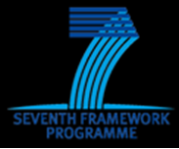
The language pairs studied are:
- Czech --> English & German
- English--> German
- German --> English
- Greek --> English & German
- Norwegian --> English & German
Near the end of the project there will be an assessment phase, where additional language pairs will be investigated, with Italian as the target language.
Features
- Development of a novel method based on generalised clustering techniques, for creating a language-independent phrase aligner adaptable to phrasing principles designated by end users
- Use of pattern recognition approaches for defining syntactic structure
- Employment of techniques inspired by functional biological systems for disambiguating translations
- Extensive use of automated optimisation techniques to define a mature system for methodically optimising system parameters
- Application of machine learning methods for allowing system adaptation
- Use of parallel computing architectures as well as mainstream multi-core architectures for PCs for substantial advances in translation speed

The PRESEMT project constitutes a novel approach to Machine Translation, characterised by the use of
(a) cross-disciplinary techniques, mainly borrowed from the machine learning and computational intelligence domains, and
(b) relatively inexpensive to compile language resources.
The aim is to develop a language-independent methodology for the creation of a flexible and adaptable MT system, the features of which ensure easy portability to new language pairs or adaptability to particular user requirements.
PRESEMT falls within the Corpus-based MT (CBMT) paradigm. The resources employed, a small bilingual corpus and a large target language (TL) monolingual one, are collected as far as possible over the web, to simplify the development of resources for new language pairs. In addition, methodologies for the extraction of information from these resources have been developed.
The key aspects of PRESEMT involve modelling based on syntactic phrases, pattern recognition approaches towards the development of a language-independent analysis and evolutionary algorithms for system optimisation.
PRESEMT has a duration of 3 years and started on 1/1/2010.

More Details about the Project

The PRESEMT (Pattern REcognition-based Statistically Enhanced MT) project is funded under "ICT-2009.2.2: Language-based Interaction".

The PRESEMT Consortium

 Coordinator: Institute for Language and Speech Processing / R.C. "Athena"
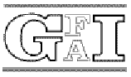 Gesellschaft zur Förderung der Angewandten Informationsforshung e.V.
 Norges Teknisk-Naturvitenskapelige Universitet
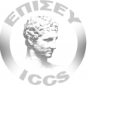 Institute of Communication and Computer Systems
 Masaryk University
 Lexical Computing Ltd.

During the TSD conference in Brno from 3 – 7 September 2012 there will be a workshop on hybrid MT where the PRESEMT project will be presented.

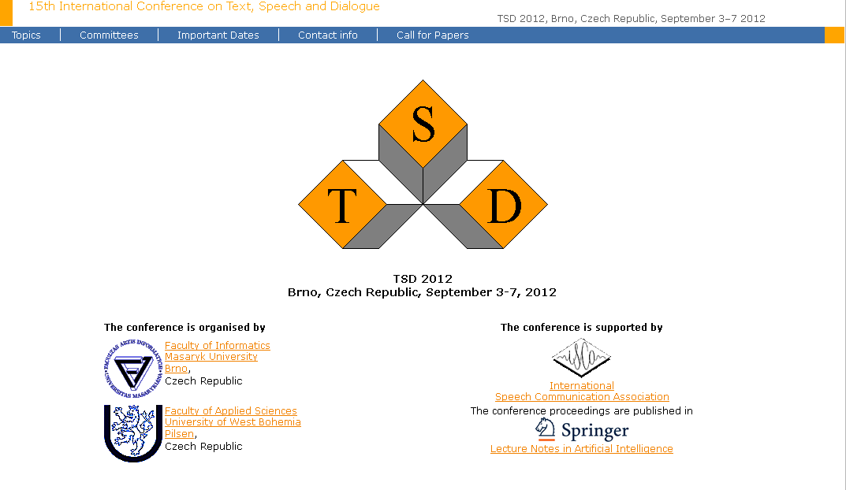

http://www.tsdconference.org/tsd2012/welcome.html

TSD 2012 Machine Translation Workshop

The TSD 2012 conference will be accompanied by a one-day satellite workshop focusing on Hybrid Machine Translation. The MT workshop will take place on September 3 2012 in the TSD-2012 conference venue.



http://presemt.cslab.ece.ntua.gr:8080/presemt_interface_test/

First Results

The project has implemented a number of language pairs. A first evaluation on the basis of some 200 sentences chosen from a corpus shows the following results for selected language pairs: In the following table, the scores for English – German are listed:

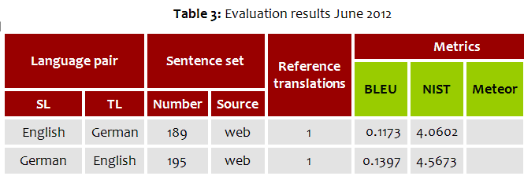

For English – Greek, the following metric values are obtained:

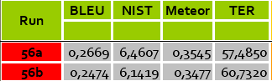

A comparison to other established systems is summarized as follows:

A comparison with other MT systems shows that PRESEMT at the present stage of development has a quality exceeding that of WordLingo and becoming comparable to Systran. Work is under way on future versions that are expected to have a further improved performance.

CONTACT:

George Tambouratzis
Head of the Machine Translation Department (ILSP)
info@presemt.eu


6, Artemidos & Epidavrou str.
151 25 Paradissos Amaroussiou
Athens
Greece

- giorg_t@ilsp.gr
- +30 210 6875411
- +30 210 6854270

http://www.ilsp.gr/homepages/tambouratzis_eng.html

